# **Assignment/LAB6**

**Task 1:**

CREATE DATABASE command used here to create a new test database on SQLSERVERUA. The database named as ProductInformation.

**Task 2:**

An SQL query is used to create the four individual tables Product,

ProductCategory, Supplier, and Inventory with the default constraints null.

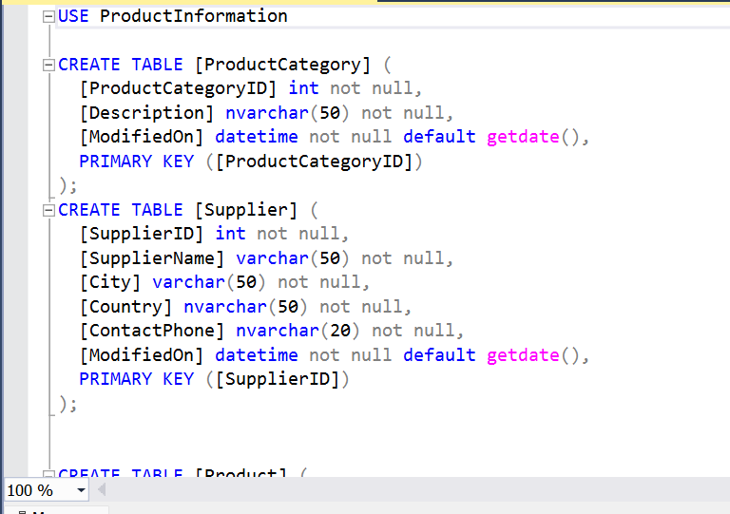

**Task 3:**

ALTER TABLE is used here to add a primary key and a foreign key in each table’s constraints.

**Task 4:**

INSERT command is used to add the sample rows to the tables. Column default is used for ModifiedOn column.

**Task 5:**

‘UPDATE’ is used to change the SupplierName of SupplierID (2) to Cuisinex.

**Task 6:**

DELETE statement contains a subquery in the WHERE clause, delete inventory records here for the Product Description.

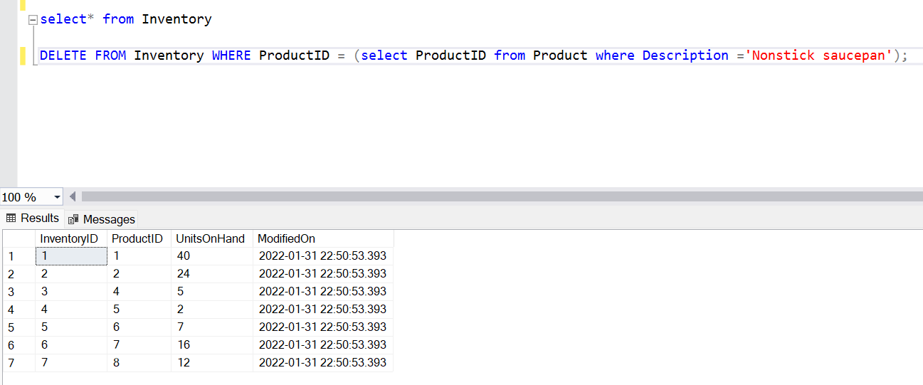

**Task 7:**

LEFT OUTER JOIN is used to retrieve all Product Descriptions that have no associated inventory there.

**Task 8:**

SELECT query is used to list the Product Descriptions and the total inventory on hand. Use a column alias to assign any calculated columns a meaningful name in the result set.

**Task 9:**

SELECT statement is used to returns the top two products with the most inventory units on hand.

**Task 10:**

Use a SELECT statement that will list the total inventory on hand. Only return records where the total inventory on hand for a product category is greater than $150. Order the output by total inventory on hand in descending order. Use a column alias to assign any calculated columns a meaningful name in the result set.

**Task 11:**

Create a view ‘vTotalInventoryByProductCategory’ that lists the ProductCategory description and the total inventory on hand.

**Task 12:**

An index is added to the Product table on the Description column.

